clean up and verification:
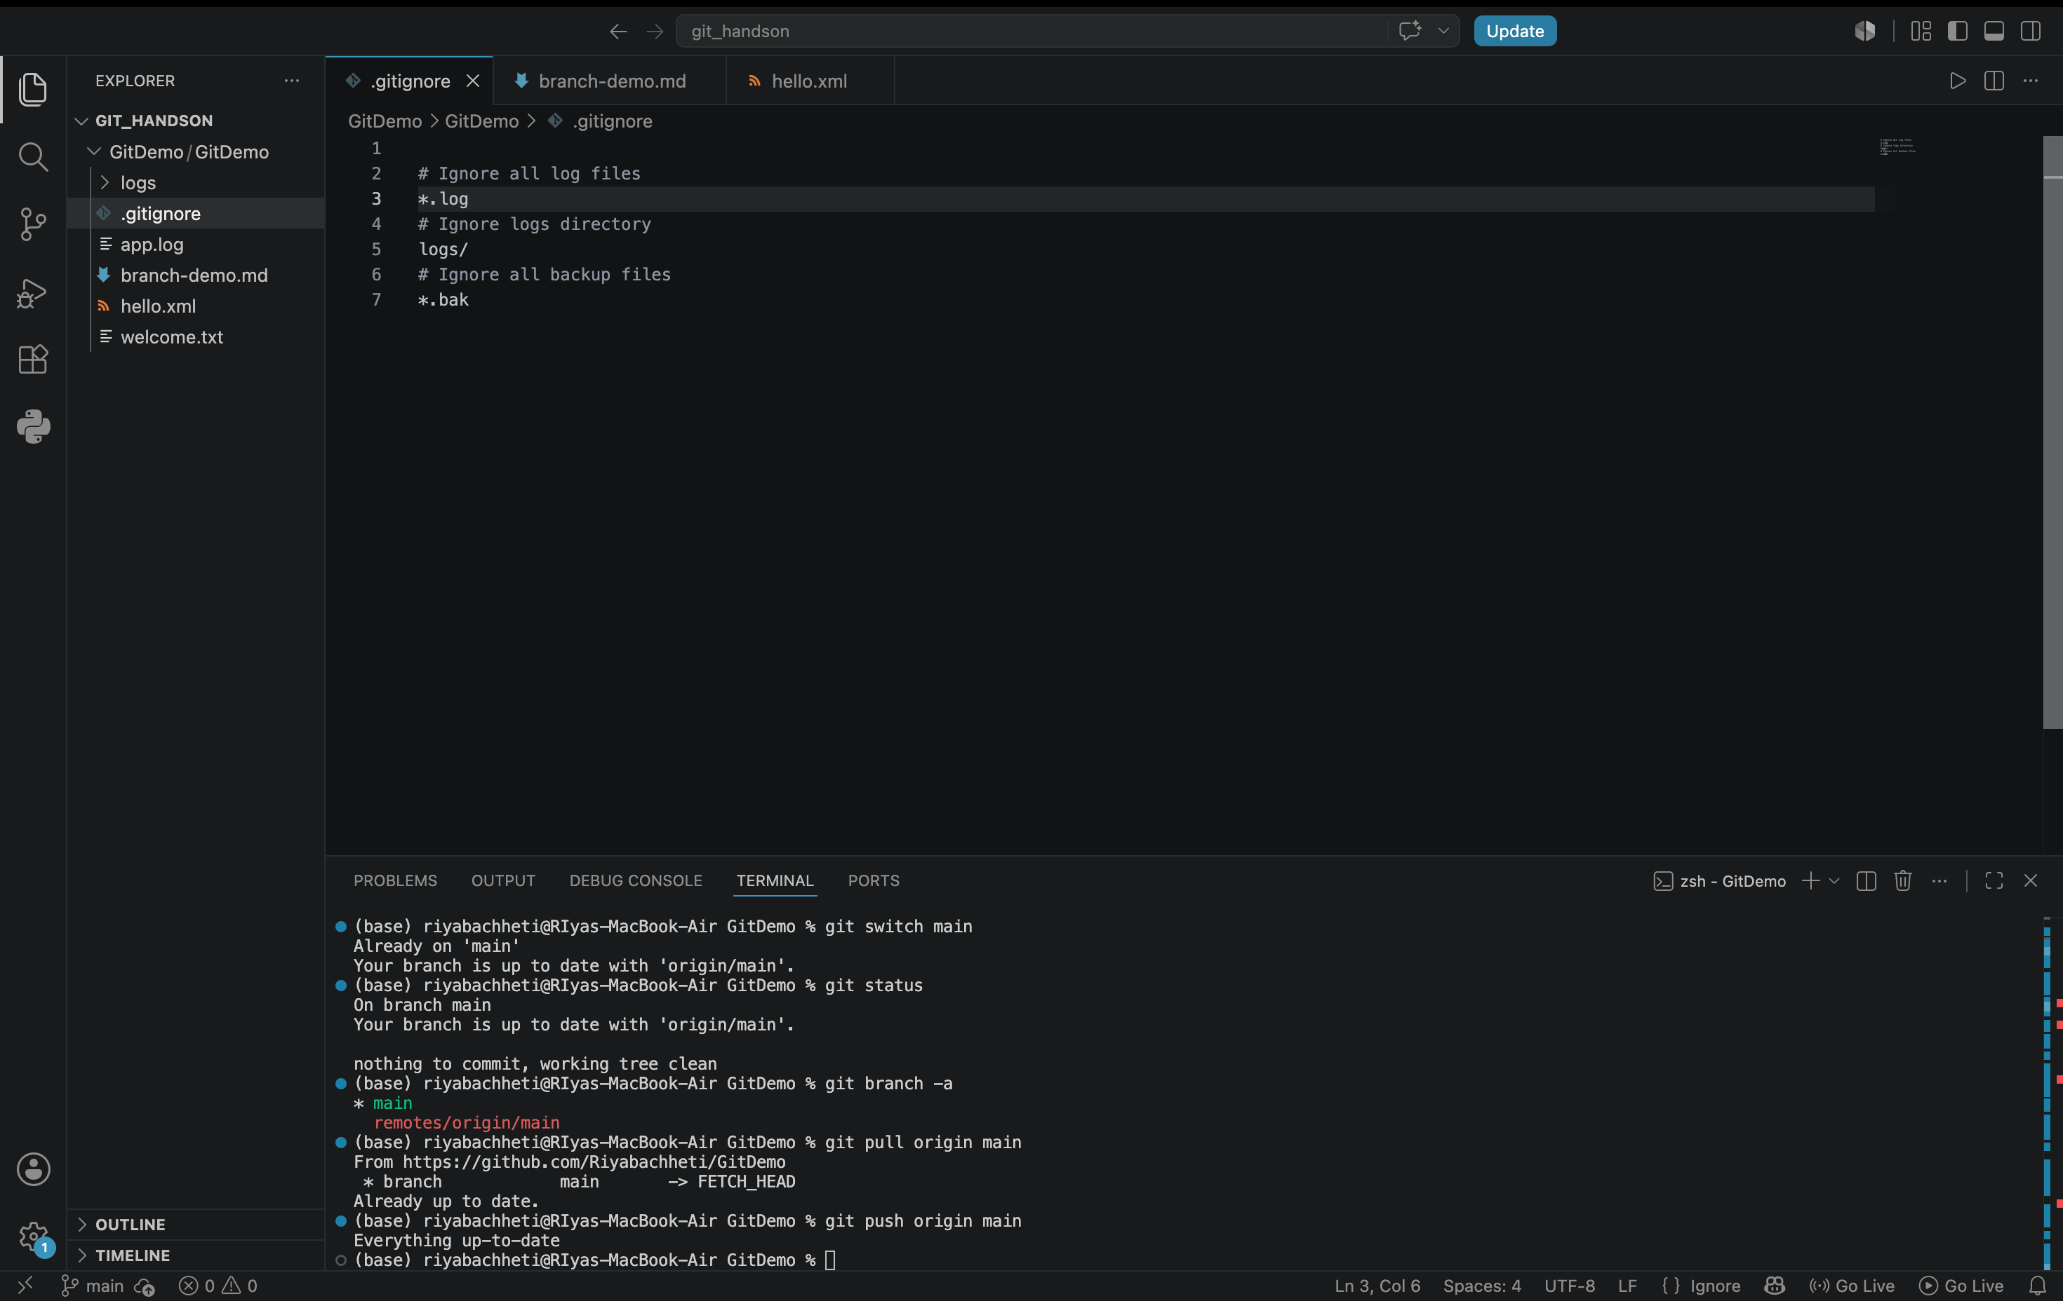

final github repository: https://github.com/Riyabachheti/GitDemo.git
